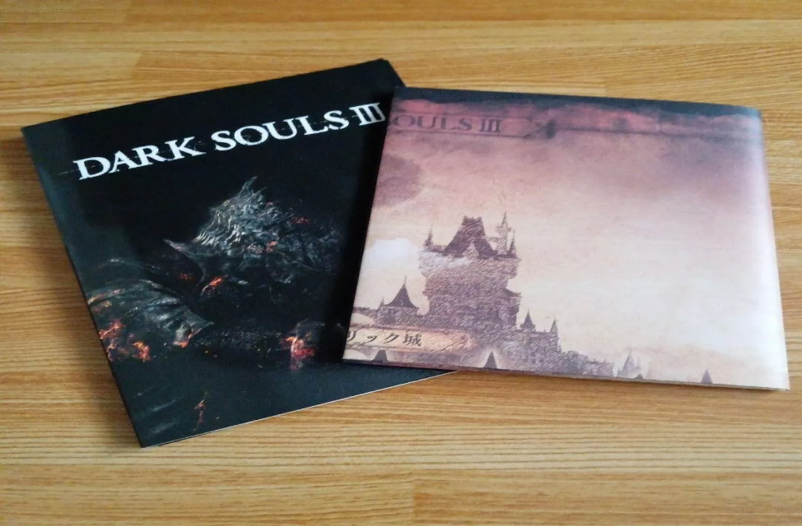

***DARK SOULS III:***

***1️. Faster & More Fluid Combat***

*Features* ***quicker movement, refined dodging, and the Weapon Arts system****, adding special abilities to weapons.*

***2️. Intense & Challenging Boss Fights***

*Includes* ***iconic multi-phase bosses*** *like* ***Pontiff Sulyvahn, Nameless King, and Soul of Cinder****, making battles unpredictable.*

***3️. Deep Lore & Dark Fantasy World***

*Set in* ***Lothric****, a world on the brink of collapse, with* ***cryptic storytelling, interconnected levels, and hidden secrets****.*

***4️. Expanded Multiplayer & Covenants***

*Allows* ***6-player online play*** *with* ***PvP invasions, co-op summons, and faction-based covenants*** *offering unique perks.*

***5️. Includes Two DLC Expansions***

*Ashes of Ariandel and The Ringed City introduce* ***new areas, enemies, bosses, and powerful weapons****.*